How to Invest When the Economy Doesn’t Make Sense Anymore
By Chris Doman | Managing Partner, Oxygen Real Estate
If the last few months have felt economically disorienting, you're not alone. Inflation is still high. Growth is slowing. The job market is softening. The Fed is divided. Yet somehow, the market just keeps chugging along. In fact, as Rick Rieder at BlackRock recently noted, the U.S. market has become remarkably adept at absorbing uncertainty and volatility, even as trade policy, tariffs, and macro shifts swirl around it.
Last week, the Federal Reserve held interest rates steady, but two Fed governors broke ranks and voted to cut rates noting a weakening labor market and growing signs of stagnation.
Now, whether or not those dissents were also subtle job applications for Fed Chair for when Jerome Powell’s term expires in May 2026, the deeper takeaway is this: there’s no clear playbook anymore. We’re living in an environment where the rules that we’ve come to adopt in the cycles since The Great Inflation of the 1980s don’t quite apply anymore, and that calls for a new kind of investment strategy.

Welcome to “Hyper-Stagflation”
Economists have a term for times like these: stagflation - a mix of sluggish growth and persistent inflation. But what we’re seeing now feels like stagflation turned up to 11.
Let’s call it what it may turn into: “hyper-stagflation”.
Inflation has remained stubbornly high, especially in services and housing. Even as GDP growth slows, consumer prices aren’t backing off. The Fed’s preferred inflation gauge is still tracking above 2.6%. Meanwhile, job creation is slipping - only 73,000 new jobs were added in July, and unemployment ticked up to 4.2%.
At the same time, real wages aren’t keeping up, fiscal deficits keep ballooning, consumer debt is at all-time highs, and productivity growth is stalling out.
It’s not a recession. It’s not a boom. It’s a murky in-between that resists easy labels, and it may stick around longer than most people think.

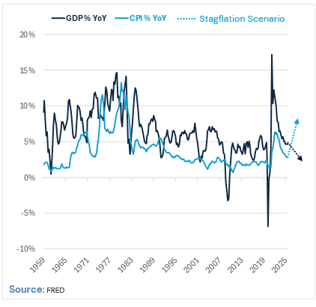

What Do You Do When the Playbook Breaks?
At Oxygen, we know we can’t predict the exact path of the economy. So, we’re building portfolios that can thrive across scenarios, and we think hyper-stagflation is the regime we should all be preparing for. That means turning conventional wisdom on its head. Here’s what we’re doing, and why:

1. Yes, We’re Comfortable with a Bit More Debt
In a hyper-inflationary world, nominal debt gets eroded over time. If rents stay flat or go up and your interest expense stays fixed, you win. We’re not advocating reckless leverage, but we are leaning into the idea that modest debt levels can be a strategic advantage when real rates turn negative.

2. We’re Open to Opportunities with Shorter Leases
Traditionally, long-term leases are seen as safer - they create predictable income. But in an inflationary environment, they can become a constraint.
That’s why we’re comfortable looking at opportunities with shorter WALTs when the fundamentals support it. These assets give us the option to reset rents more frequently and stay aligned with rising price levels.
We don’t actively avoid longer leases - but we see value in flexibility when inflation is part of the backdrop.

3. We’re Focused on Real Assets with Built-In Resilience
We target infill urban properties, mixed-use assets, and locations where supply is constrained but demand is durable – places with strong, consistent cash flow that survive market disruptions. They pass inflation through to rents, maintain liquidity when capital markets seize, and most importantly, generate enough operating cash flow (what we call “oxygen”) to weather any storm. When credit disappears, these properties keep breathing.

4. We’re Building for Both Outcomes
Best case scenario – the economy recovers? Our assets capture upside through rent growth and appreciation.
Worst case – prolonged stagflation? We hyper-outperform: our fixed-rate debt erodes with inflation; shorter-term leases equal frequent rent resets; strong cash flow covers debt with room to spare.
We’re not betting on one outcome, and we’re structuring profits from either.

Tariffs and Policy Uncertainty Add to the Mix
Tariffs are just the latest wildcard. They’re disrupting supply chains, distorting prices, and freezing corporate decision-making. As many have noted, the real damage isn’t inflation – it's uncertainty. Companies can’t plan. Investors can’t price risk. This is exactly why Oxygen seeks optionality into everything: flexible lease terms, adaptable capital structures, multiple exit strategies. When policy changes tweet by tweet, you need assets that can pivot just as fast.

A Final Word: Don’t Wait for Clarity That May Never Come
What if the next 3–5 years are defined by persistent inflation, muddled growth, volatile policy, and rising geopolitical risk?
In that kind of world, the best-positioned investors will be the ones who didn’t run from the uncertainty, but found a playbook that that had enough optionality to persevere under multiple outcomes.

